**Statistical Analyses**

From the data gathered, the Pearson Coefficient was calculated for each relationship between leadership and cultural variables. They were separated into the global leadership dimensions and the societal-level cultural values. The six leadership dimensions variables examined were the charismatic, team-oriented, self-protective, participative, human-oriented, and the autonomous dimension Performance orientation and future orientation were the two cultural dimensions. Overall, twelve correlations were performed between the leadership dimensions and the cultural dimensions.

**Results**

From the analysis, twelve Pearson’s r correlations.were found. Each correlation was for one hypothesis. The first group consisted of six correlations which calculated the relationship between performance orientation and the leadership dimensions. The second group consisted of six correlations which calculated the relationship between future orientation and the leadership dimensions.

Hypothesis one consists of *H0*: r = 0 and *Ha*: r ≠ 0 for the variables of performance orientation and charismatic leadership. It was found that r = 0.215, p-value = 0.093 which led to accepting the null hypothesis. The results can be seen in figure 1.

**Figure 1**

*Correlation between Performance Orientation and Charismatic Leadership*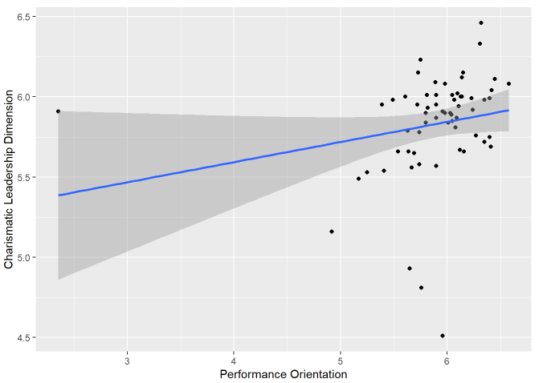

*Note.* The line represents the general trend of the data. The shaded area represents the confidence interval.

Hypothesis two consists of *H0*: r = 0 and *Ha*: r ≠ 0 for the variables of performance orientation and team-oriented leadership. It was found that r = 0.195, p-value = 0.128 which led to accepting the null hypothesis. The results can be seen in figure 2.

**Figure 2**

*Correlation between Performance Orientation and Team-Oriented Leadership*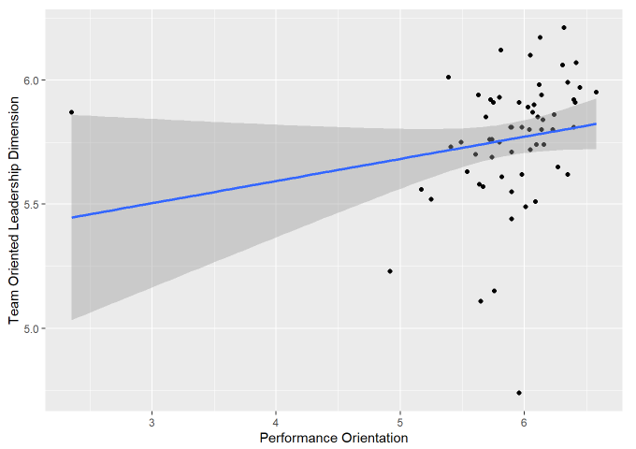

*Note.* The line represents the general trend of the data. The shaded area represents the confidence interval.

Hypothesis three consists of *H0*: r = 0 and *Ha*: r ≠ 0 for the variables of performance orientation and self-protective leadership. It was found that r = 0.028 with p-value = 0.8306 which led to accepting the null hypothesis. The results can be seen in figure 3.

**Figure 3**

*Correlation between Performance Orientation and Self-Protective Leadership*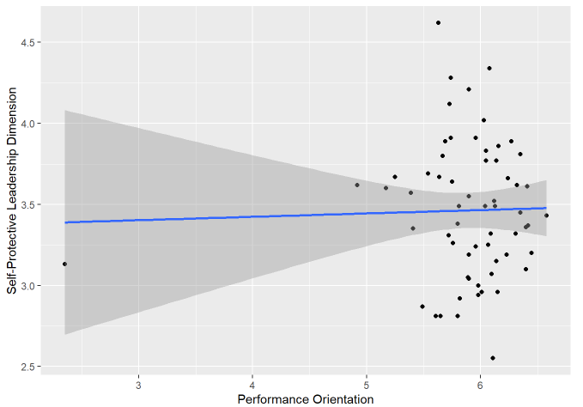

*Note.* The line represents the general trend of the data. The shaded area represents the confidence interval.

Hypothesis four consists of *H0*: r = 0 and *Ha*: r ≠ 0 for the variables of performance orientation and participative leadership. It was found that r = 0.054 with p-value = 0.676 which led to accepting the null hypothesis. The results can be seen in figure 4.

**Figure 4**

*Correlation between Performance Orientation and Participative Leadership*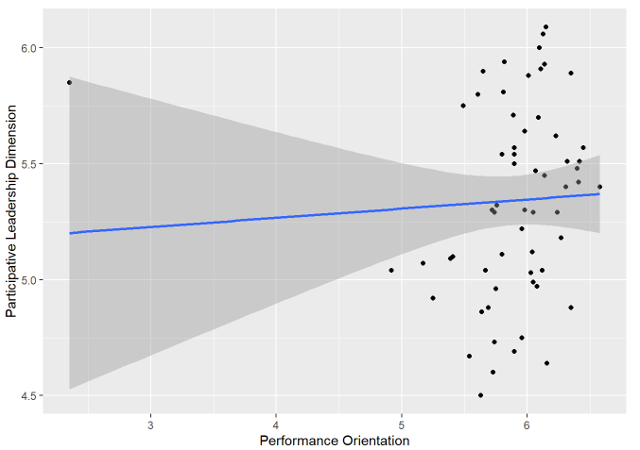

*Note.* The line represents the general trend of the data. The shaded area represents the confidence interval.

Hypothesis five consists of *H0*: r = 0 and *Ha*: r ≠ 0 for the variables of performance orientation and humane-oriented leadership. It was found that r = 0.191 with p-value = 0.138 which led to accepting the null hypothesis. The results can be seen in figure 5.

**Figure 5**

*Correlation between Performance Orientation and Humane-Oriented Leadership*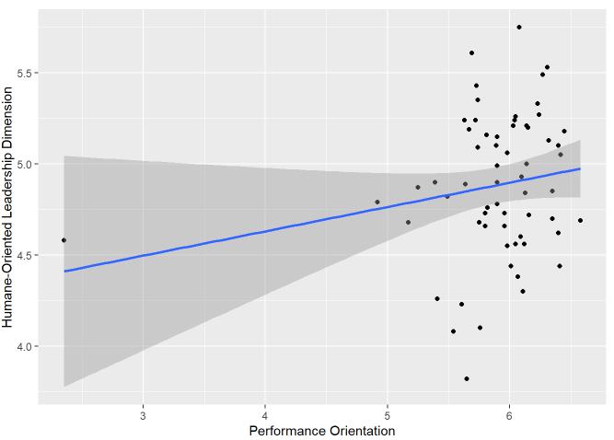

*Note.* The line represents the general trend of the data. The shaded area represents the confidence interval.

Hypothesis six consists of *H0*: r = 0 and *Ha*: r ≠ 0 for the variables of performance orientation and autonomous leadership. It was found that r = -0.355 with p-value = 0.005 which led to rejecting the null hypothesis and accepting the alternative hypothesis. The results can be seen in figure 6.

**Figure 6**

*Correlation between Performance Orientation and Autonomous Leadership*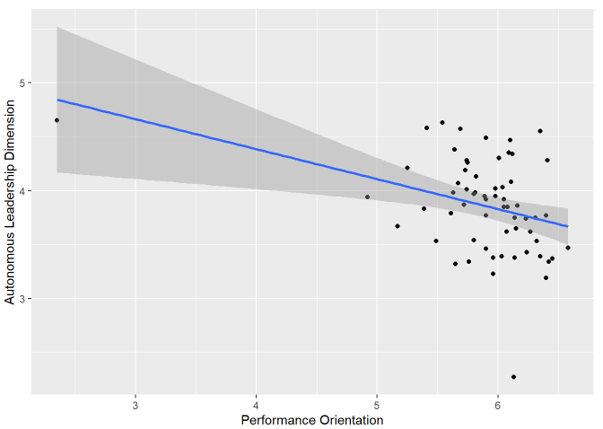

*Note.* The line represents the general trend of the data. The shaded area represents the confidence interval.

Hypothesis seven consists of *H0*: r = 0 and *Ha*: r ≠ 0 for the variables of future orientation and charismatic leadership. It was found that r = 0.013 with p-value = 0.922 which led to accepting the null hypothesis. The results can be seen in figure 7.

**Figure 7**

*Correlation between Future Orientation and Charismatic Leadership*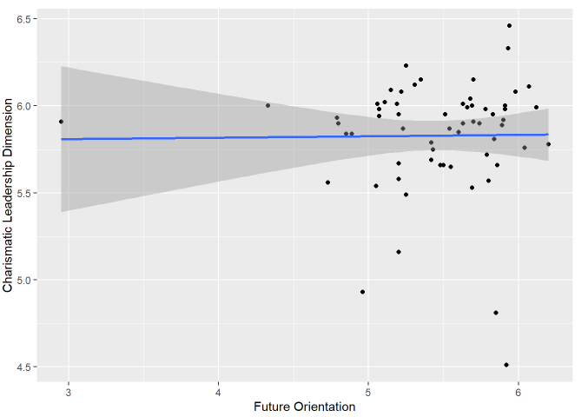

*Note.* The line represents the general trend of the data. The shaded area represents the confidence interval.

Hypothesis eight consists of *H0*: r = 0 and *Ha*: r ≠ 0 for the variables of future orientation and team-oriented leadership. It was found that r = 0.128 with p-value = 0.321 which led to accepting the null hypothesis. The results can be seen in figure 8.

**Figure 8**

*Correlation between Future Orientation and Team-Oriented Leadership*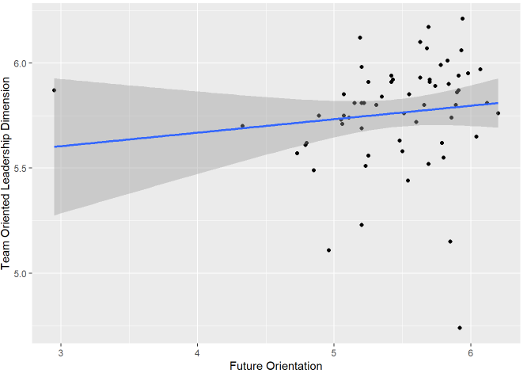

*Note.* The line represents the general trend of the data. The shaded area represents the confidence interval.

Hypothesis nine consists of *H0*: r = 0 and *Ha*: r ≠ 0 for the variables of future orientation and self-protective leadership. It was found that r = 0.437 with p-value = 0.0004 which led to rejecting the null hypothesis and accepting the alternative hypothesis. The results can be seen in figure 9.

**Figure 9**

*Correlation between Future Orientation and Self-Protective Leadership*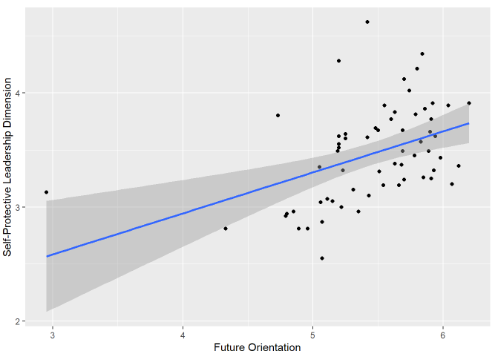

*Note.* The line represents the general trend of the data. The shaded area represents the confidence interval.

Hypothesis ten consists of *H0*: r = 0 and *Ha*: r ≠ 0 for the variables of future orientation and participative leadership. It was found that r = -0.345 with p-value = 0.006 which led to rejecting the null hypothesis and accepting the alternative hypothesis. The results can be seen in figure 10.

**Figure 10**

*Correlation between Future Orientation and Participative Leadership*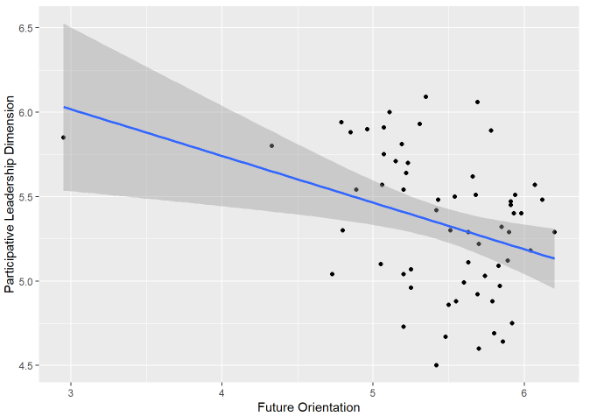

*Note.* The line represents the general trend of the data. The shaded area represents the confidence interval.

Hypothesis eleven consists of *H0*: r = 0 and *Ha*: r ≠ 0 for the variables of future orientation and humane-oriented leadership. It was found that r = 0.347 with p-value = 0.006 which led to rejecting the null hypothesis and accepting the alternative hypothesis. The results can be seen in figure 11.

**Figure 11**

*Correlation between Future Orientation and Humane-Oriented Leadership*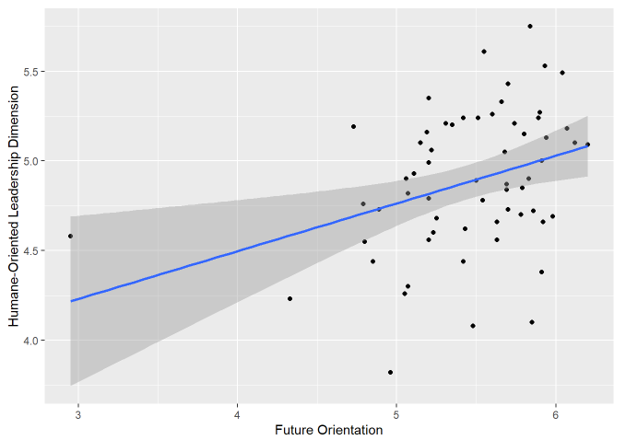

*Note.* The line represents the general trend of the data. The shaded area represents the confidence interval.

Hypothesis twelve consists of *H0*: r = 0 and *Ha*: r ≠ 0 for the variables of future orientation and autonomous leadership. It was found that r = -0.357 with p-value = 0.004 which led to rejecting the null hypothesis and accepting the alternative hypothesis. The results can be seen in figure 12.

**Figure 12**

*Correlation between Future Orientation and Autonomous Leadership*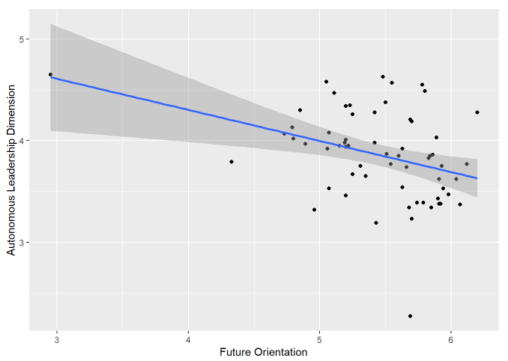

*Note.* The line represents the general trend of the data. The shaded area represents the confidence interval.